**Advanced Sprint Part 4**

**Carl Wentzel**

**PowerBi Report**

**Insights Plan – Questions**

With this advanced sprint part in PowerBI, I want to put myself in a perspective of a Real Estate Agent, and what I would want to be on the visual, with the data provided in mind.

**House Value**

The data that is represented are the property value and location of the property.

Interesting representation of what customers are looking to buy in Australia, and perhaps all over the world are the location, the median property value in the area (the middle point of the data).

Some basic insights as well such as:

* How much property are available in the area of choice?
* What are the min/max/median/average house values in the area of choice?
* Given the range bucket of House Value, allow to select the bucket range and display just those related results.

With this in mind, the facts (house value) can be broken into if categories. As cheap and expensive is subjective, the categories will be more simplified for the house values.

i.e. If house value is less than or equal to 500k, then the house value is from 0-500k, if house value is between 500k and 1M then the house value is 500k-1M etc.

**Rental Value**

* How much Rentals are available in the area of choice?
* What are the min/max/median/average rental values in the area of choice?
* Given the range bucket of rental value, allow to select the bucket range and display just those related results.

**School**

* How many schools are available in the area of choice?
* What schools types are available in the area of choice?

**Transport**

* What transportation stops are available in the area of choice?

**Crime**

* What are the most reported crime in the area of choice?
* In Australia, which state, city and suburb have the highest crime reported?
* A summary of crime categories and subcategories reported in the area of choice.

**Design**

The design I was aiming for is subtle on they eyes with contrasting visuals, and interesting interactions. This was derived from the color wheel which had influenced the colors of black, orange and grey.

Thes colours were further derived from creating an interactive menu by having a side pane with buttons, that can be selected, and have a menu open.

Defualt:

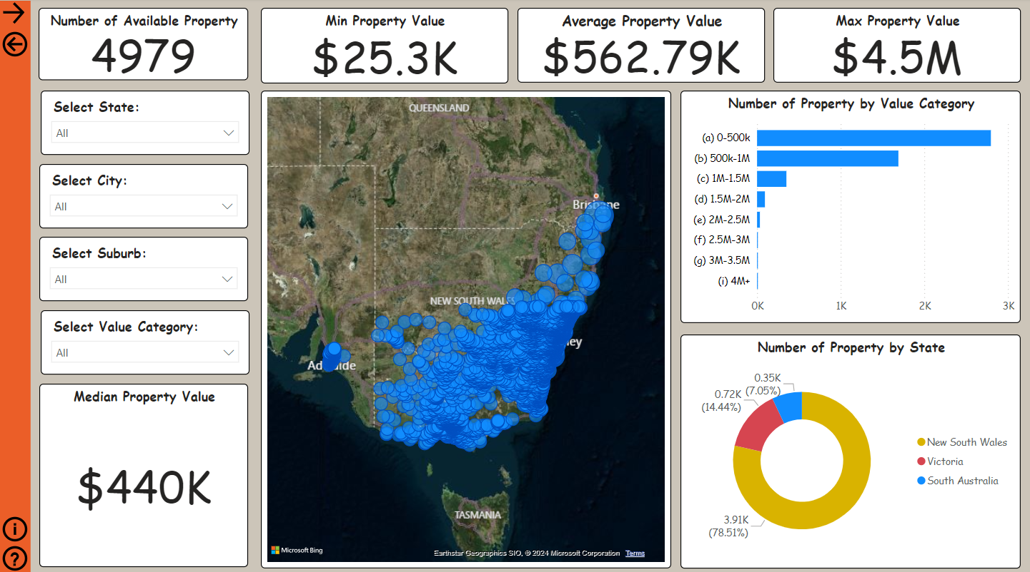

Navigation Menu:

By selecting anywhere on the screen, I am able to go back to the defulat view as it’s a large transparent button overlaying the data visuals.

This is repeated across all pages for consistency.

Now you’re wondering how did I do this?

This was done by the use of custom navigation found here:

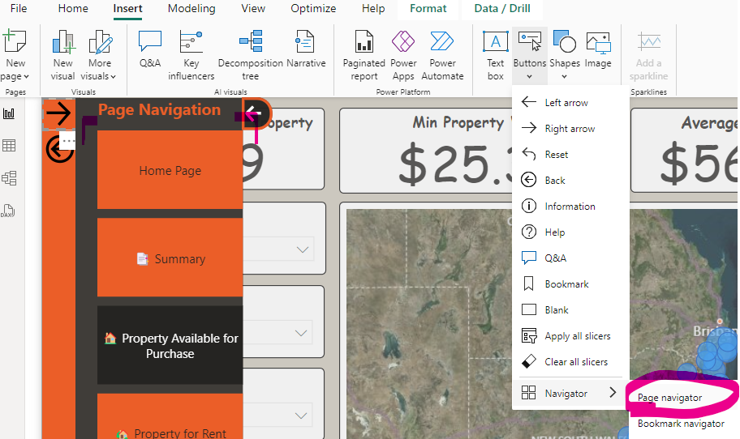

* The background is just extra shapes to bring the contrasting to life.
* Buttons are designed by defualt, hover and onlcick as well as when on the page.
* Additional buttons customized are added to the left hand side.

The challenging part was getting everything to interact. This was done by referencing bookmarks.

First I had to make sure ever button and shape in relation to the menu were dealt with accordingly:

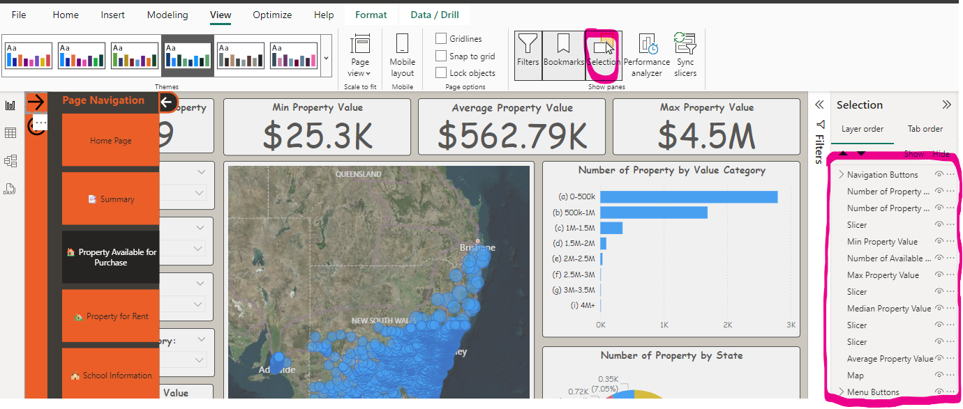

By default, nothing has been named, so each item will be shown as the default name. To make my life easier, I named every single shape and button in relation to the menu.

The great thing about the selection pane is that things can be grouped to act as a singluar item, which will be useful when creating the navigation open and close.

By doing this, I have grouped the navigation buttons, and I have grouped the menu buttons (side wall) as shown in the screenshot above.

Furthermore, with the button placed in the centre of the screen, I could have bookmarks to represent the output of how I’d want the dashboard to look like when the navigation is open, and closed.

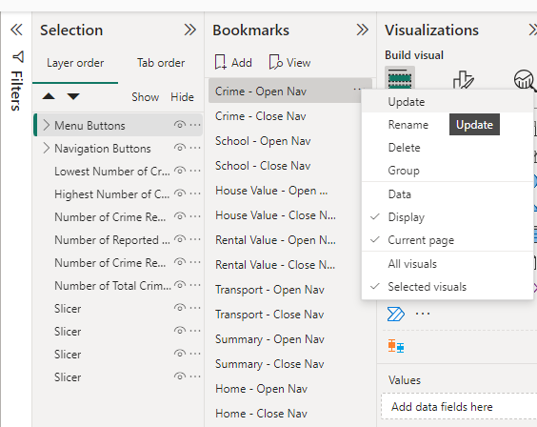

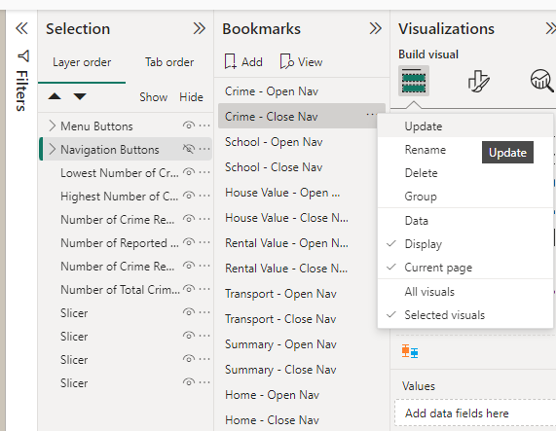

Once the bookmarks were created, the buttons could then be mapped:

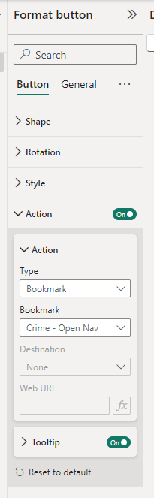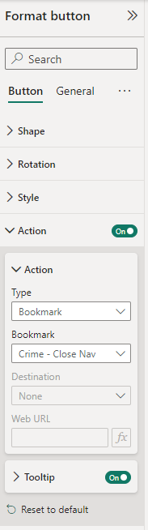

After testing and ensuring that the navigation has worked as intended, I then duplicated the result to the rest of my pages so that the result is consistent throughout the collection of dashboards.

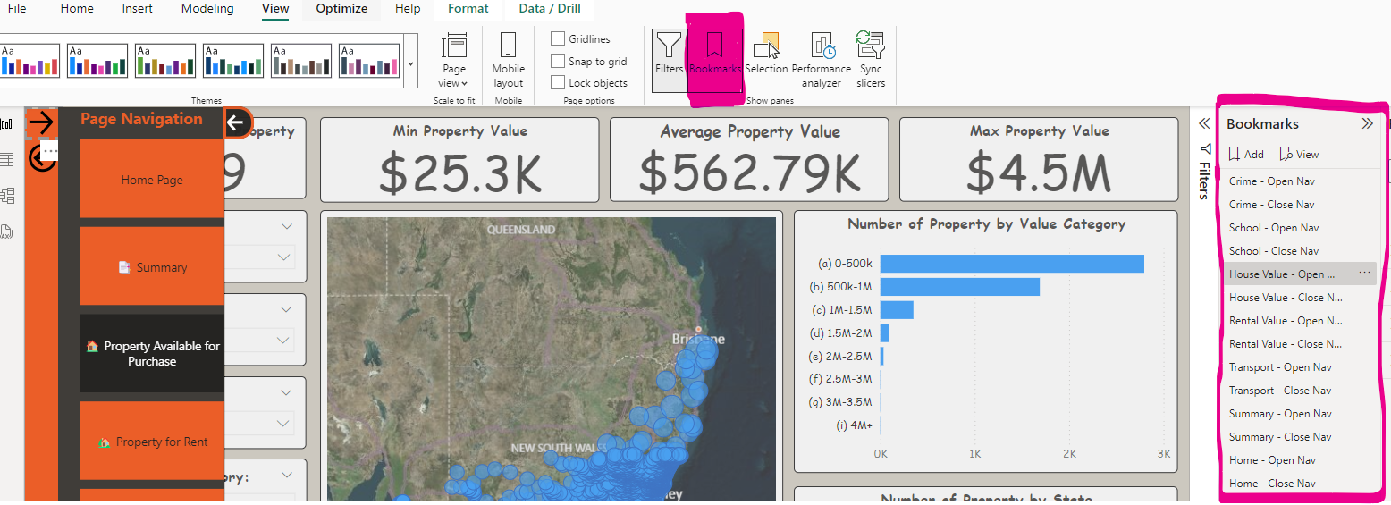

**Mapping Distance to the center point of a city**

I wanted to make the experience for a Real Estate Agent communicating potential houses, schools etc more precise to look for a better word.

Often those wanting homes want a house, or a rental close to the city as that might be where they work, or for easier access to the city or for whatever reason. With this in mind, I added a distance function given the lattitude of all the locations around NSW, VIC and SA. The distance function has the lat and long for every majour city in each of the states, and is then calculated using trigonometry.

Further details in calculation are below:

Distance_From_Sydney = ACOS(SIN(-33.8678*PI()/180)

* SIN(Dim_AusGeo[lat]*PI()/180)

+ COS(-33.8678*PI()/180)

* COS(Dim_AusGeo[lat]

* PI ()/180)

*COS(Dim_AusGeo[lon]

*PI()/180-151.2100

* PI()/180) ) * 6371

Where the lat: in grey and long: in purple is the pin point location.

Each column are independent to each major city location, and returns the distance in KM.

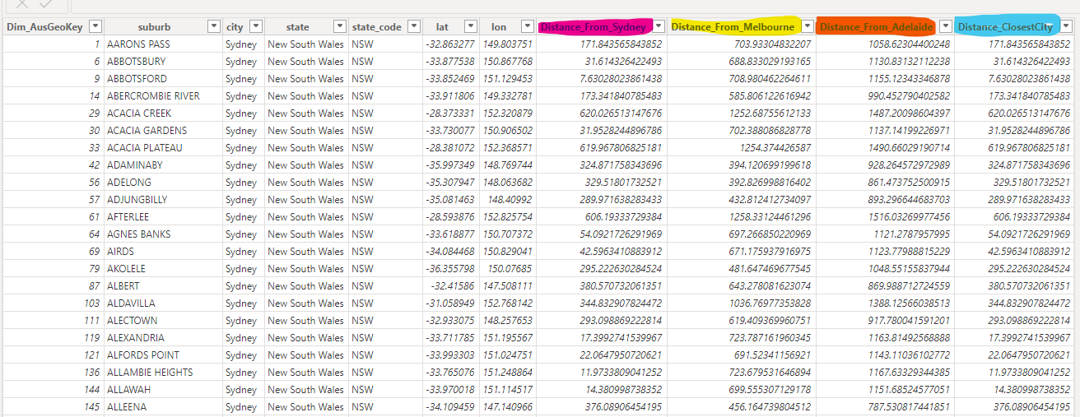



This can then be used as a slider in each of the different dashboard where relevant for better analysis on houses, rentals, schools, train stops and the crime in the different areas.

**Managing Roles**

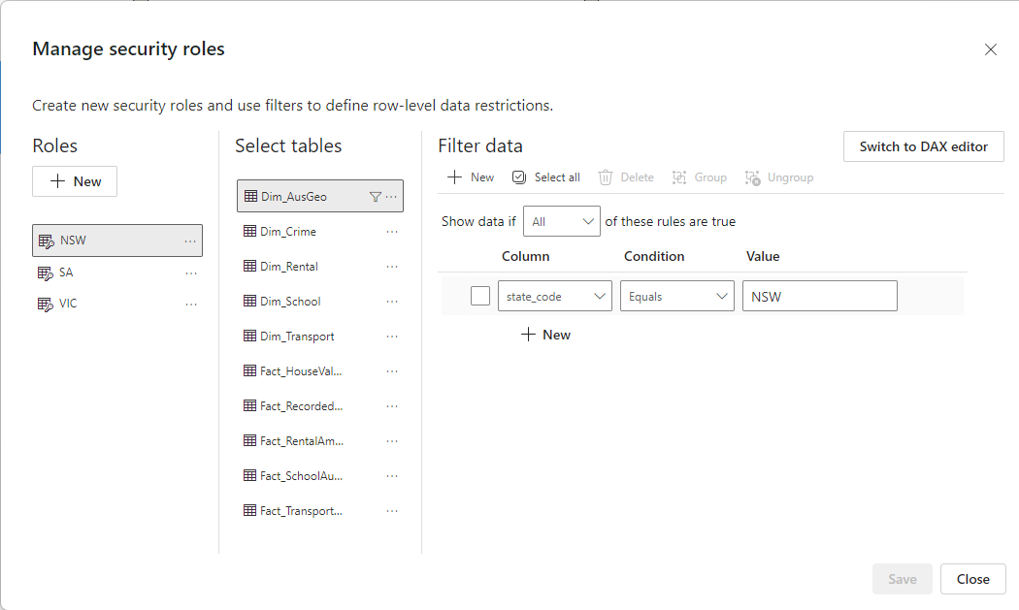

Roles are managed by filtering down the data by state_code. By doing this, I have created a filter for each state the data is relevant to. NSW, SA and VIC.

By selecting view as, I am able to cycle through the selection or go back to default.

**Summary Page**

I found the summary page to be a little challenging, as I didn’t really know what to put here.

I eventually thought of an idea to have something that I’d feel would be of a highlight from each dashboard into one.

* Average Rental Amount in Each State
* Average House Valie in Each State
* Percentage oof Total Reported Crimes by State
* Number of Stops by State
* Number of Schools by Type

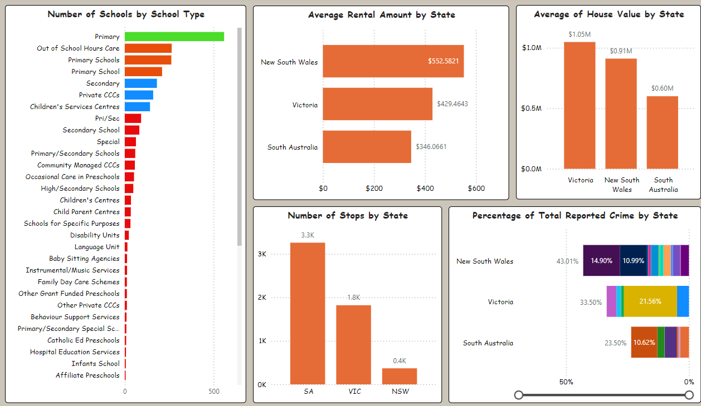

At first glance, this may cause a bit of interest to the user to feel like they want to explore more. This comes down to the drill down feature which will allow the user to filter from the summary page, to the dashboard of choice for futher insight.

Furthermore, the PowerBI report will be found in the folder for an indepth look.

**Thank you**

**Advanced Sprint Part 5**

**Carl Wentzel**

**PowerBI – Matrix/SSRS Report Link**

At first I had no idea how to achieve the linkage, but with curiosity of how, I wanted to explore the optional tasks.

The direction was that I needed to understand how to pass parameters from PowerBi to SSRS Report.

Through research, the first thing I had to do was create a URL that takes parameter inputs and test it:

**Link that I have to the report, i.e. House_Value Report**

http://prototype-6:8080/Reports/report/AdvancedSprint/HouseValue_Report

**Design of the path as instructed**

http://<YourReportServer>/ReportServer/Pages/ReportViewer.aspx?ItemPath=<ReportPath>&Parameter1=<Value1>&Parameter2=<Value2>

**Testing The Path**

http://prototype-6:8080/Reports/report/AdvancedSprint/HouseValue_Report?StateParam=South%20Australia&CityParam=Adelaide&SuburbParam=DAVOREN%20PARK

Note: &20 is space in a URL

**Creating the Path**

http://prototype-6:8080/Reports/report/AdvancedSprint/HouseValue_Report?StateParam=<Value1>&CityParam=<Value2>&SuburbParam=<Value3>

**Creating he Path custom to PowerBI inputs using DAX in a measure**

SSRSLinkHouseValue_Report =

SUBSTITUTE("http://prototype-6:8080/Reports/report/AdvancedSprint/HouseValue_Report?"

& "StateParam=" & SELECTEDVALUE(Dim_AusGeo[state])

& "&CityParam=" & SELECTEDVALUE(Dim_AusGeo[city])

& "&SuburbParam=" & SELECTEDVALUE(Dim_AusGeo[suburb]), " ", "%20")

* Substitute was required to replace the spaces with %20 for the URL to be successful.
* Selectedvalue is from the selected state/city/suburb, to be inserted into the URL as parameters.
* & is to concatinate the strings together.

The measure was not directly added to the matrix, however, was used as reference to a button that can be pressed after the parameters have been selected.

This was then repeated for all dashboards remaining (Rental/Crime/School/Transport)

**Design**

The design of the matrix was placed in its own small window similar to the navigation, and can be opened and closed clicking the bottom left book mark icon/clicking the open space.

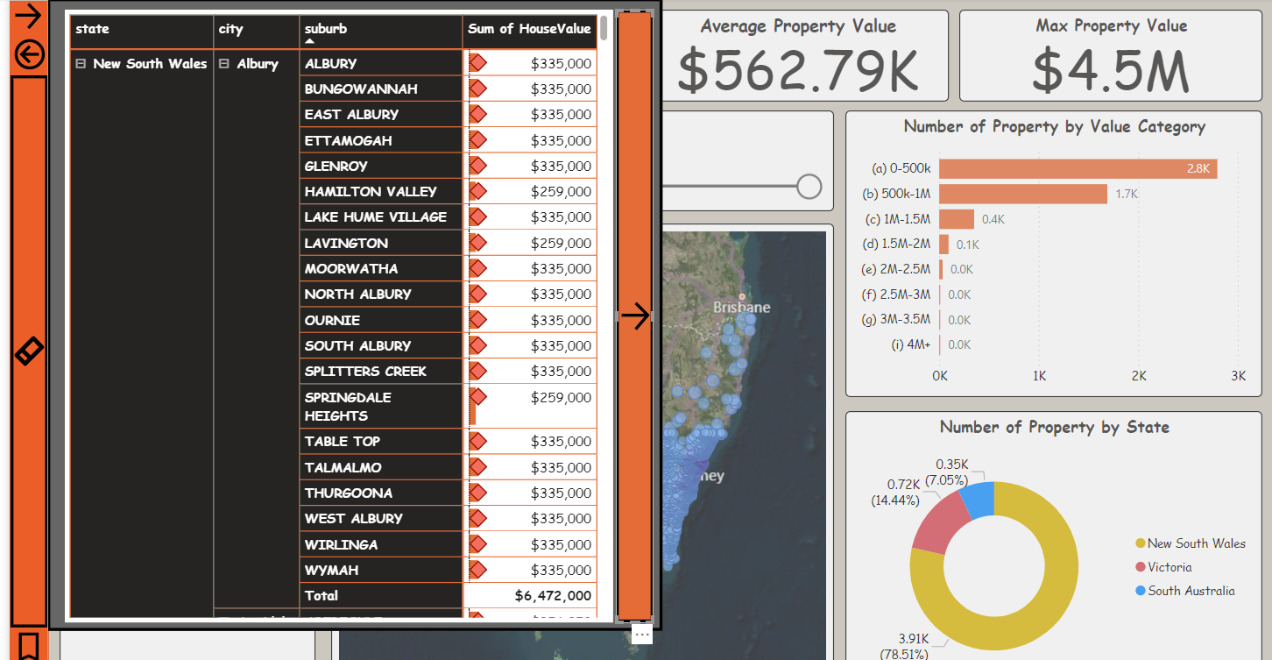

Select suburb and click the long button on the right hand side to access the SSRS report with the selection as parameter inputs:

**Thank you**